**Directions for running a Direct Certification Report in the Michigan Student Data System (MSDS)**

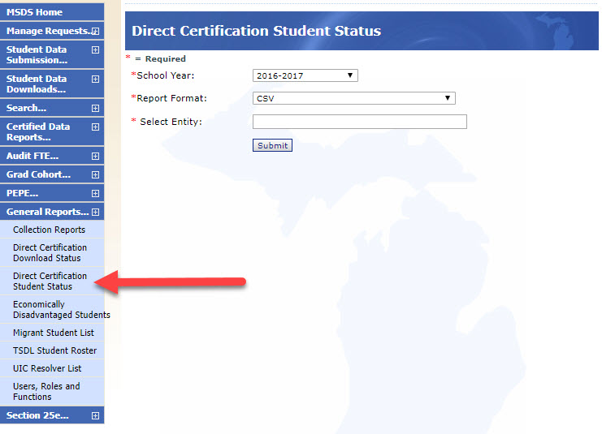

From MSDS, under “General Reports…”, click “Direct Cert. Student Status.”

Select the school year, “CSV” as the format, and the entity.

Filter the column headers in Excel. Under “EligCat,” filter for “F” (Foster).